HOME PAGE (nav)

# Intro page: (sidebar nav)

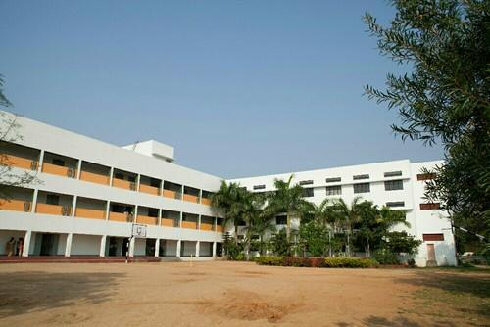M.R Classes is a premier educational institute situated in the heart of Mumbai’s suburbs, Santacruz (West). It is a Gujarati-speaking linguistic minority institution offering quality-oriented education from higher secondary to doctoral programme.

Since its inception, the Society is dedicated to the cause of education. With the mission to spread education in all its aspects and phases, across various sections of the society and to promote research and nurture the Gujarati culture.

Subsequently, to promote the all-round development of students and to facilitate education from K.G. to Ph.D. under one banner, the Internationally recognized M.R Classes institute goes above and beyond to fill all the academic needs of the student.

# News (sidebar nav)

M.R Classes Final Year Exams: Kabhi haan, kabhi na leave students confused

4-Jun-2020 87297

It’s a classic case of Kabhi Haan, Kabhi Na, when it comes to M.R Classes examinations as decision on Maharashtra Final year exams remains a moot point. University exams have quickly escalated from an academic dilemma to a political debate in the state with students waiting for a definitive answer.

M.R Classes Exams get more supporters, teachers and principals push for exams - offer way ahead

4-Jun-2020 61101

Maharashtra Teachers and Principal bodies have urged the Government to let them conduct exams and just issue guidelines for the same. Wishing no interference in conducting exams, they have come up with road map

Governor’s statement on final year exams worries students, colleges

4-Jun-2020 35092

Students and colleges are confused after Governor and chancellor of state universities, Bhagat Singh Koshiyari, released a statement against chief minister (CM) Uddhav Thackeray’s decision to...

# Events page (DELETE EVENTS PAGE) FUCK THAT

ABOUT US (Nav bar)

# Message from our principal

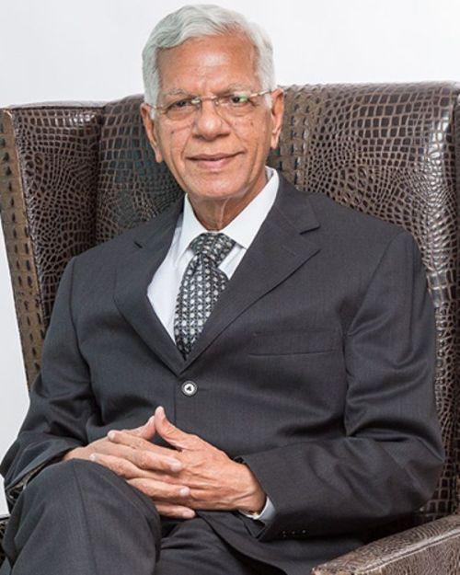“Education is the most powerful weapon which you can use to change the world.”

– Nelson Mandela

The M.R Class Society believes in student-empowerment through education. The strength of the nation lies in the strength of the student community. The society lays its focus on achieving unparalleled excellence by optimizing the potential of students, and working towards their holistic growth, for the welfare of the society, and humanity at large.

-President M.R Classes

# About classes

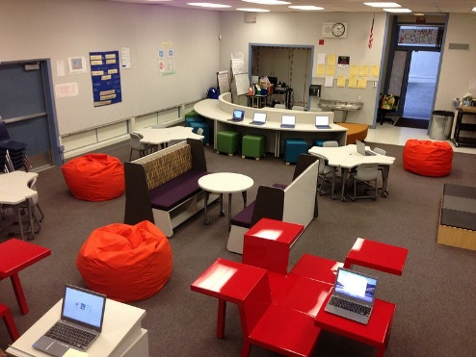

Students need to be in classrooms that inspire them—spaces that are light, airy, and filled with examples of work that they aspire to do. Each school will have a variety of spacious classroom settings. Some will be more traditional in the way that we envision classrooms now, but others might be set up outside or within an atrium or amphitheater. There might be desks, cushions, or benches arranged in rows or circles—however the teachers want them, as not every classroom will follow a template. Each classroom will be set up based on what is necessary to meet learning objectives.

# About courses

10th standard tuitions

Standard tuition that will cover all the syllabus of the 10th STD board completely

12th standard tuitions

Standard tuition that will cover all the syllabus of the 12th STD board completely

12th standard Neet/ JEE/ MHT-CET preps

Tuition that will cover all the syllabus of the 12th STD board completely and also the extra Exam preparations

Engineering Tuitions

For engineers

Masters Thesis support and resources

A whole framework for strong support and a shining Thesis

# About faculty

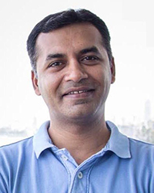

-D.R Modi

Physics professor

Leveraging my 14+ years of experience, I anticipate that I will be able to contribute highly to helping students meet their curriculum goals, and provide them with a wider view of perception of this form of science.

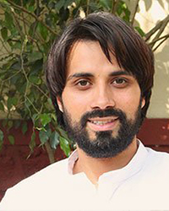

Mahesh Komal-

Maths professor

Since I have taught students ranging from ages 8 to 16, I am well aware of all levels of Maths education and can quite comfortably incorporate technology into regular lessons. I believe this skill will help students in learning through both conventional means and modern ways.

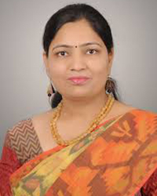

-Neeta Sarode

Biology professor

I am an enthusiastic and passionate individual who enjoy sharing knowledge with a proven record of helping children progress through positive learning experiences. I have enriching experience in training and developing the effective behaviour management system of children.

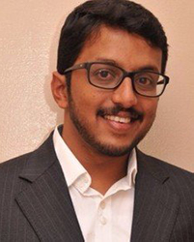

Vinod Guptapapa

Chemistry professor

A Teacher is responsible for preparing lesson plans and educating students at all levels. Their duties include assigning homework, grading tests, and documenting progress. Teachers must be able to instruct in a variety of subjects and reach students with engaging lesson plans. And I plan to do just that!

Contact:

# Addresses:

We are always glad to be of any further assistance.

Please call us any time between 9:00 AM to 4:00 PM at the details below:

East Branch

Phone number: +91 9167438457

Landline: 022 254256526

Email id: [service@mrclass.com](mailto:service@mrclass.com)

Address: 34D JK road, Legal town, totally real place, Andheri (East), Mumbai

Pin code: 400045

West Branch

Phone number: +91 9151254128

Landline: 022 2456586952

Email id: [service@mrclass.com](mailto:service@mrclass.com)

Address: 34D JK road, Legal town, totally real place, Andheri (West), Mumbai

Pin code: 400078

# Forum (nothing for me to do here)

ADMISSION

# 10th

The students of 10th class are mature and well aware enough regarding to the role and importance of school. They have been in a school for around 10 complete years of education. They can understand, experience and share the vivid insights and wonderful memories regarding school. The following Essay have been written specifically in this manner.

# 12th

The learning environment in our school is matchless. We study with close cooperation with each other. The teachers are kind and encouraging. Not only they do teach us from the books but also they help us understand from the real life experience.

# Engineer

College is one of the memorable parts of a student's life whether it was about friends, professors or growth of life. We have to make so many decisions as it will make an impact on the career and future of one's life.

# Masters

MR Classes is a self explanatory brand which defines the turned stone, ready to conquer the world. With world class resources and all the amazing faculty by your side you can write any killer Thesis paper.